Instructions for using the Groups Toolbox
The first step is to ensure that you have an account in the Rock database. Go to https://trygrace.org/myaccount
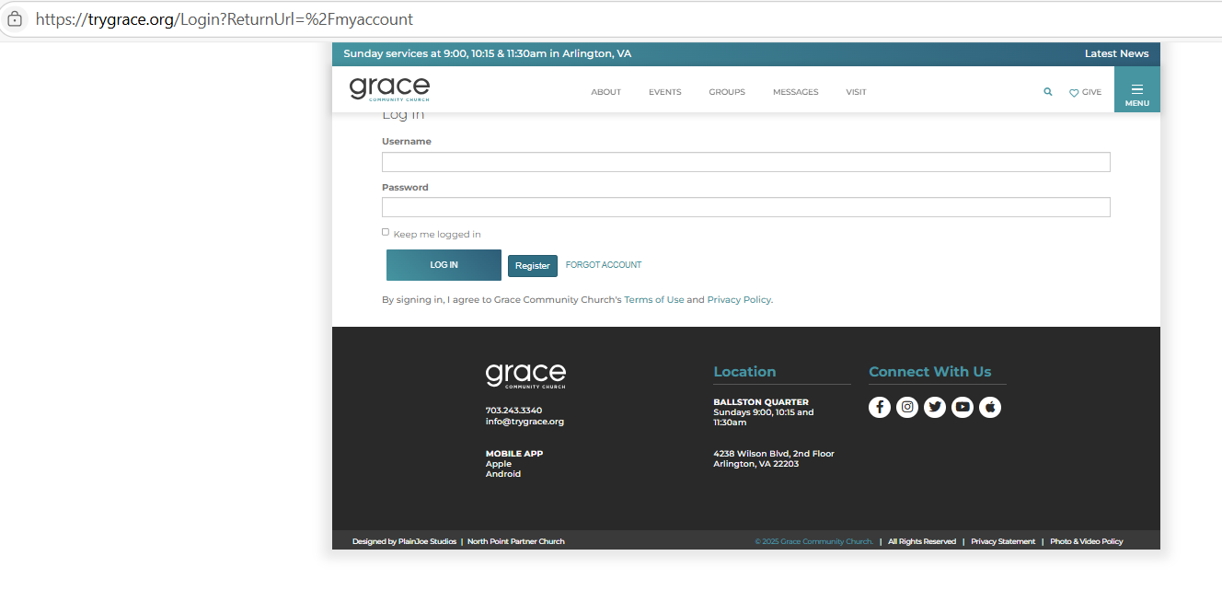
Enter your account username and password if you have one.
Click on “Forgot Account” if you don’t remember.
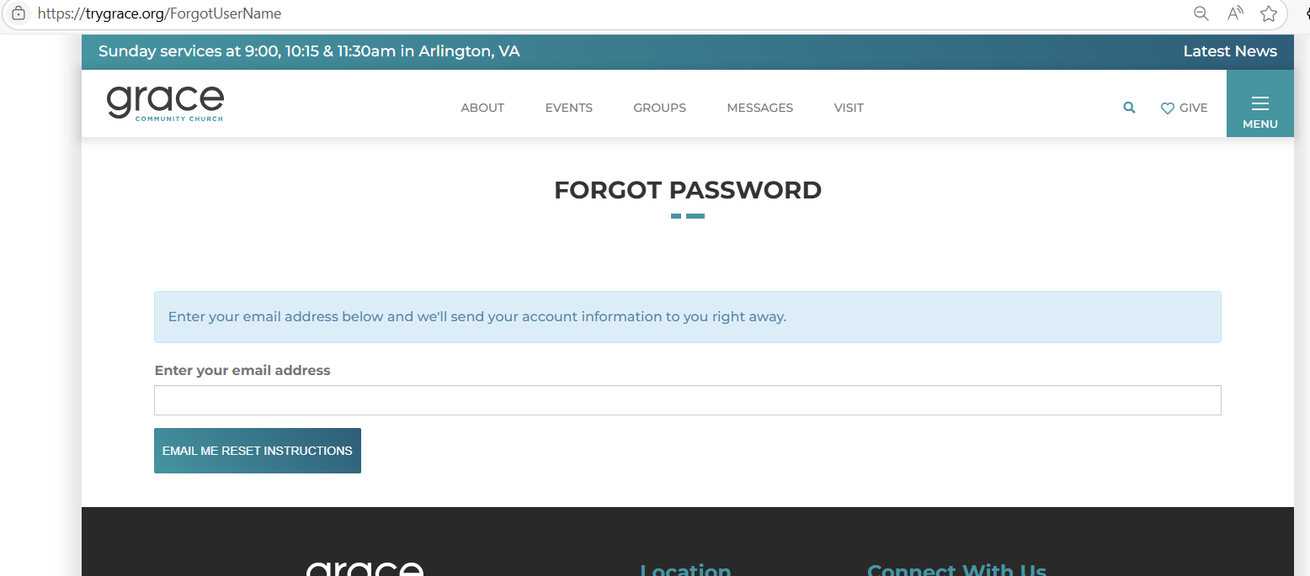

Click on Register, if you do not have an account.
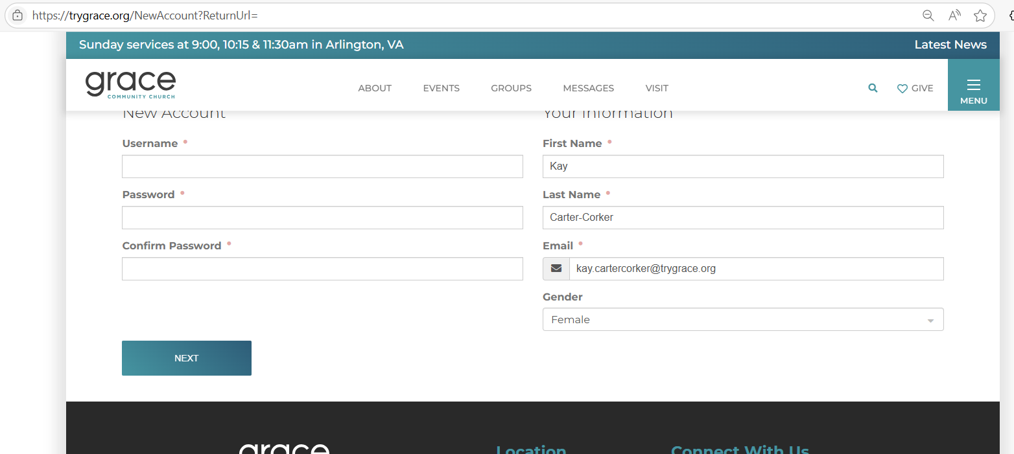
After you have your account established, you may now see the Grace website home page. 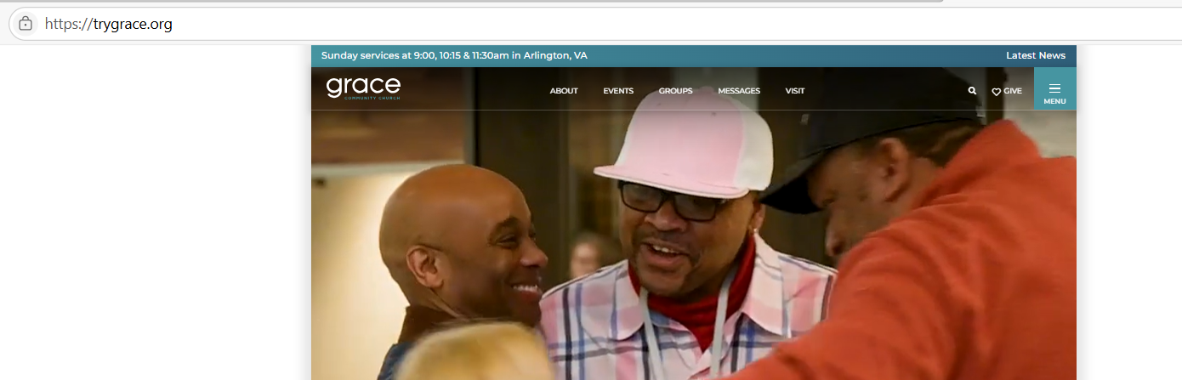Add /myaccount to the navigation. Click on “Log In”.
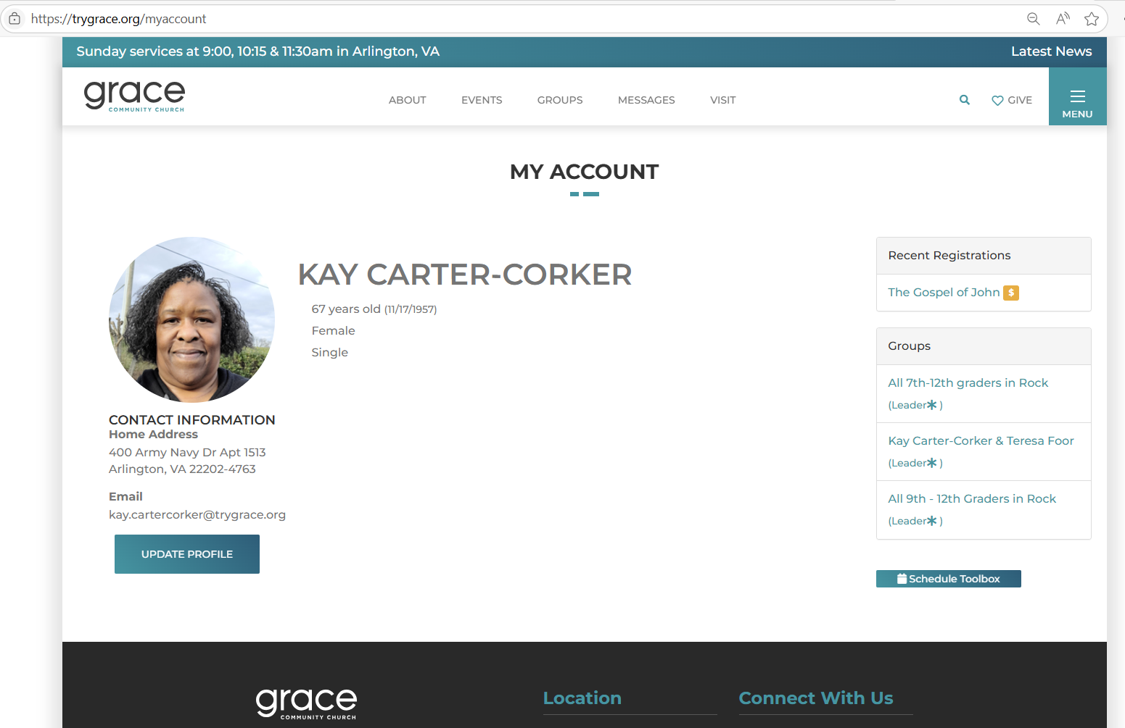

Click on the group you want to review (in the right hand panel). See the list of ladies in your group.
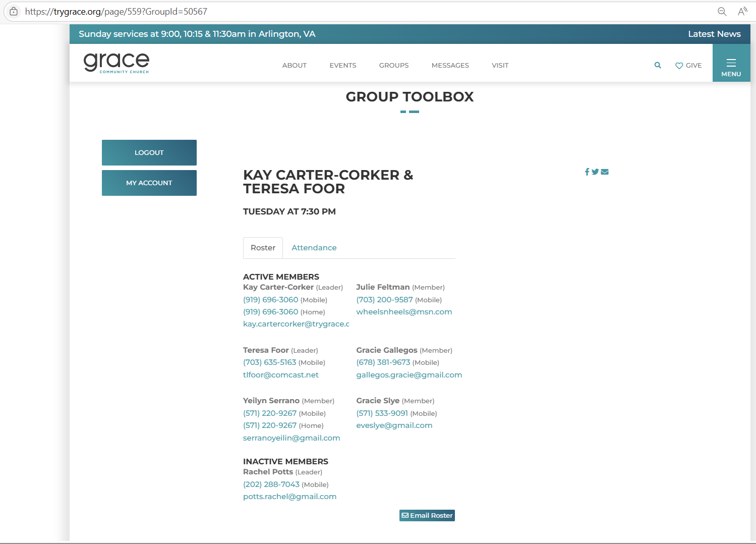

Click on “Email Roster” if you want to send your group an email message.
Enter the “Subject” of your mail. Enter your message. Click on “Send Communication”.

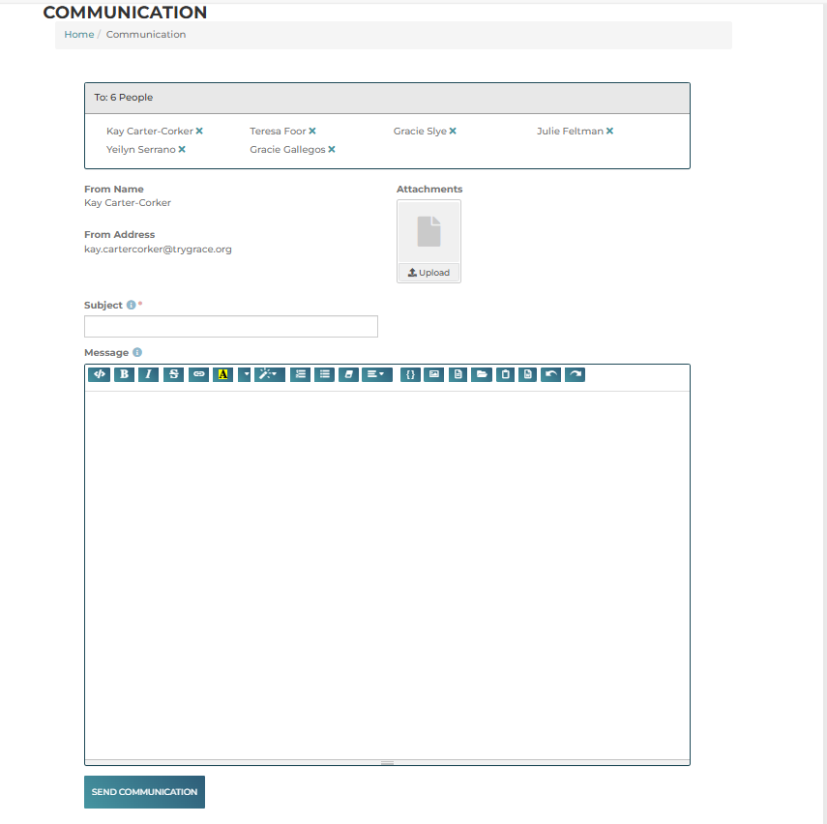

Click the “back arrow” to return to the group roster page.
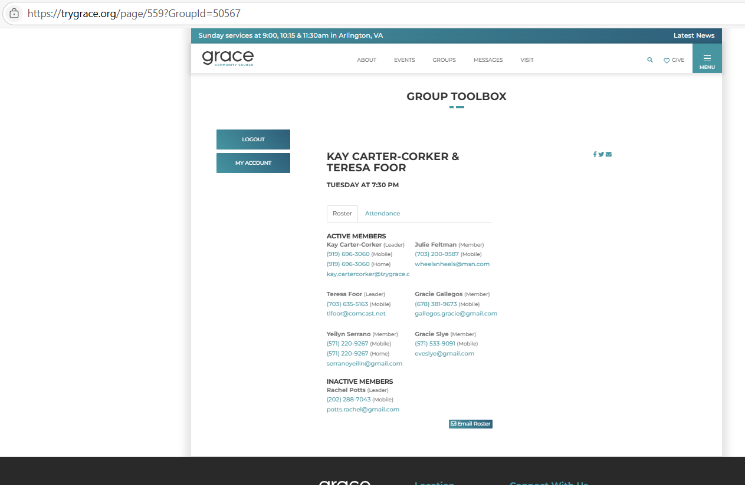
Click on “Log Out”.

